Algebra 1: Unit 9, Lesson 5

- Luis is solving the equation, $8k^{2}=392$, but did not finish his work. Complete the final step to find the solutions to the equation.
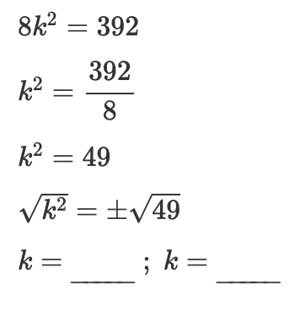
$-7$ and $7$

- Find the value for $p$ in the equation, $0=42p^{2}-672$, by completing the missing steps.
$$0=42p^{2}-672 \\ 672=42p^{2} \\ \frac{672}{42}= p^{2} \\ 16= p^{2} \\ \sqrt{16}=\sqrt{p^{2}}$$_______$=p$
$-4$ and $4$

- The graph of $y=0.25{(x+4)}^{2}+2$is shown.
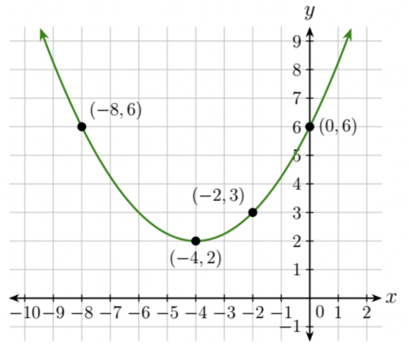
The horizontal line, $y=2$, shows that there is/are ______________ solution(s) for $0.25{(x+4)}^{2}+2$.
$$1$$

